Contents
When first saving your new document, Do References > ! Update Table > Update Entire Table, to update this section's initial contents.
(Don't attempt to modify the rest of this section manually.)
2 Introduction 1
3 This Is How Your Immune System Reacts to Coronavirus 1
3.1 And what it means for treatment 1
4 Appendixes 1

Introduction
This page constitutes commentary on a thought-provoking and insightful document.
You are encouraged to see the document in its original context unless you are interested in this Commentary Markup by Frederick N. Chase.
The markup is only via
i) emphasis (red, bold, underline, yellow highlight or font size), ii) [pink bracketed commentary],
iii) hypertext linking of a term or statement to a web page believed to offer quick uncontroversial augmentation and
iv) omission (elision) of material - by a series of dots somewhat proportional to the amount of original material elided.
This page is part of the homeplace web portal. Homeplace is advertisement-free.

This Is How Your Immune System Reacts to Coronavirus
From: https://elemental.medium.com/this-is-how-your-immune-system-reacts-to-coronavirus-cbf5271e530e

And what it means for treatment

Dana G Smith
Mar 24 · 6 min read

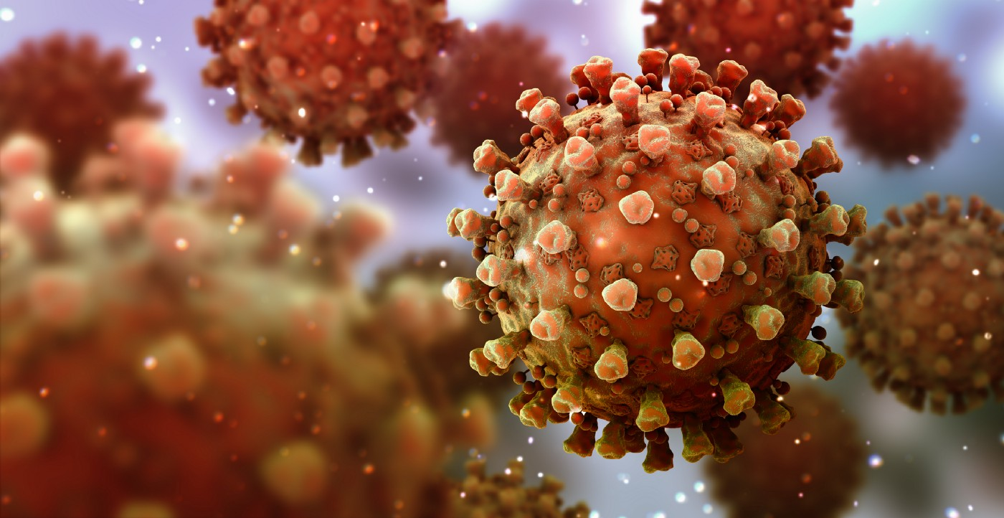
Photo: Bertrand Blay/iStock/Getty Images Plus
People infected with the novel coronavirus can have markedly different experiences. Some report having nothing more than symptoms of a mild cold; others are hospitalized and even die as their lungs become inflamed and fill up with fluid. How can the same virus result in such different outcomes?
Scientists are still perplexed by the novel coronavirus. But it’s becoming increasingly clear that the immune system plays a critical role in whether you recover from the virus or you die from it. In fact, most coronavirus-related deaths are due to the immune system going haywire in its response, not damage caused by the virus itself. So what exactly is happening in your body when you get the virus, and who is at risk for a more severe infection?
In fact, most coronavirus-related deaths are due to the immune system going haywire in its response, not damage caused by the virus itself.
When you first become infected, your body launches its standard innate immune defense like it would for any virus. This involves the release of proteins called interferons that interfere with the virus’s ability to replicate inside the body’s cells. Interferons also recruit other immune cells to come and attack the virus in order to stop it from spreading. Ideally, this initial response enables the body to gain control over the infection quickly, although the virus has its own defenses to blunt or escape the interferon effect.
The innate immune response is behind many of the symptoms you experience when you’re sick. These symptoms typically serve two purposes: One is to alert the body that an attack has occurred — this is thought to be one of the roles of fever, for example. The other purpose is to try and get rid of the virus, such as expelling the microscopic particles through cough or diarrhea.
“What typically happens is that there is a period where the virus establishes itself, and the body starts to respond to it, and that’s what we refer to as mild symptoms,” says Mandeep Mehra, MD, a professor of medicine at Harvard Medical School and chair in advanced cardiovascular medicine at Brigham and Women’s Hospital. “A fever occurs. If the virus establishes itself in the respiratory tract, you develop a cough. If the virus establishes itself in the gastrointestinal mucosal tract, you’ll develop diarrhea.”
These very different symptoms emerge depending on where in the body the virus takes hold. The novel coronavirus gains entry into a cell by latching onto a specific protein called the ACE2 receptor that sits on the cell’s surface. These receptors are most abundant in the lungs, which is why Covid-19 is considered a respiratory illness. However, the second-highest number of ACE2 receptors are in the intestines, which could explain why many people with the coronavirus experience diarrhea.
“Because the virus is acquired through droplets, if it comes into your mouth and enters your oropharynx, it has two places where it can go from there. It can transition into the lung from the oropharynx when you breathe in, or if you have a swallow reflex, it’ll go down to your stomach,” Mehra says. “That’s how it can affect both sites.”
The goal of the innate immune defense is to contain the virus and prevent it from replicating too widely so that the second wave of the immune system — the adaptive, or virus-specific response — has enough time to kick in before things get out of hand. The adaptive immune response consists of virus-specific antibodies and T cells that the body develops that can recognize and more quickly destroy the virus. These antibodies are also what provide immunity and protect people from becoming reinfected with the virus after they’ve already had it.

In some people, however, the virus will replicate and spread rapidly before the immune system wrestles it under control. One reason this can happen is if a high quantity of viral particles infect the body — which is why doctors and nurses, who are exposed to huge amounts of the virus multiple times a day caring for patients, can have more severe infections even if they are young and healthy. The more virus there is, the harder it is for the immune system to manage.
Another reason the body can lose control over the virus lies in the immune system itself. The most vulnerable populations during the pandemic are elderly people, whose immune systems naturally start to decline with age, and people who are immunosuppressed because of another illness or medication. A suppressed immune system can result in a weaker initial interferon response or a delayed antibody response, allowing the virus to spread from cell to cell relatively unchecked.
“The people that do the worst, the ones where it leads to death, almost invariably will have this exaggerated host response — the cytokine storm.”
“If you make a good neutralizing antibody response, you’re going to be able to recover; it’s just a timing issue. People get sick, but then they make their antibody response, they clear the virus, and everything is fine,” says Warner Greene, MD, PhD, director of the Gladstone Center for HIV Cure Research and a professor of microbiology and immunology at the University of California, San Francisco. “Individuals who are older or have underlying health problems maybe have a degree of immunosuppression, which delays the antibody response, and they’re the ones that have the exaggerated disease course.”

If the virus is able to take up residence in the lungs, the disease can progress to pneumonia as more cells become infected and inflamed. Part of the damage is caused by the virus, but an even greater amount is due to the immune system itself trying to destroy and get rid of those infected cells.
At this point, the disease can still go in two directions: The immune response can remain stable and regain control over the virus, eventually clearing it through T cell and antibody activity. Or the immune system can freak out and start to overrespond, churning out more and more inflammatory proteins, called cytokines, in a frantic attempt to wipe out the virus. It’s this second path that causes substantial cell death in the lungs, resulting in the most severe infections, acute respiratory distress syndrome, and even death.
“The people that do the worst, the ones where it leads to death, almost invariably will have this exaggerated host response — the cytokine storm,” Greene says. “The lungs fill up with fluid, and they can’t oxygenate. Or they develop widespread sepsis, can’t support their blood pressure, and die. All of this is either primarily driven by or greatly exacerbated by the host [immune] response.”
The elderly and immunocompromised are particularly vulnerable to this type of response as their underactive immune system suddenly kicks into hyperdrive and becomes overactive. “There’s a really interesting curiosity in Covid-19 — plus we’ve observed it with other coronaviruses as well, like with SARS and with MERS — that the people who have the most suppressed immune responses seem to develop the most aberrant immune responses in the later stages of disease,” Mehra says.
Most of the clinical trials conducted so far have involved treating these severe cases, which on the surface makes sense — you want to give the potentially effective drugs to the sickest people in case it can help save them.
But Mehra, who has a paper coming out this week on the different stages of the disease, thinks it might be too late at this point because you no longer only need to quash the infection, you also need to temper the immune system itself. He proposes that antiviral drugs be given earlier, when people are just starting to get sick, to help them fight the virus more effectively and prevent them from progressing to the later stages. For people who are already experiencing the cytokine storm, immune-suppressing drugs in combination with antivirals may be most beneficial.
The most important takeaway, he says, is that “there are different stages of this disease, and how you apply treatment at which phase of the disease will carry a lot of weight in terms of patient outcome.”
For now, your best defense against the virus is to support your immune system with sleep, exercise, and good nutrition and, most importantly, to wash your hands and practice social distancing so you don’t get infected in the first place.

Appendixes
- No Appendixes to this document.

